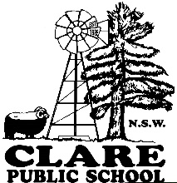

Permission Note
Sean Choolburra performance
30 August 2022

Clare Public School students have been invited to attend Sean Choolburra Performance:

Date: Monday 19th September
Venue: Balranald Central School Hall
Travel: Parents/Private vehicle
Time: 11:30 am (Arrive by 11:15 am and meet Mr Selby and Kara at the front gate) finishes at 1pm
Cost: Nil (school will pay for lunch)
At completion of event, lunch and play at Balranald Discovery Cafe

Please bring drinks, have recess before getting to the School.
Please ensure your child brings hat, drink bottle and sunscreen.
Students are to wear their school uniform.

Please complete the consent form and return to the school by Friday 16th September.

This school event has the approval of the Principal.

Kathy Bourke
Principal
------------------------------------------------------------------------------------------------------------------------------

Sean Choolburra Performance
I hereby consent to _______________________________ of year ______ participating in the Sean Choolburra Performance on Monday 19th September.

My child/children will be travelling with Myself Other ______________________________

Signed _________________________ Print Name____________________________

Date __________________

Special needs of my child of which you should be aware (e.g. allergies, medication – please provide full details.

Medication (please state) ________________________________________________________________

Asthma epilepsy other (please state)

Allergies (please state)______________________________________________________________

Allergy to the following medication/s: ___________________________________________________________________________

Other (please state) __________________________________________________________

