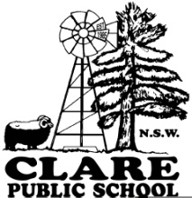 | Clare Public School  Booligal Road via Balranald NSW 2715  T 03 5020 6896 F 03 5020 6896  Email: clare-p.school@det.nsw.edu.au  Principal: Kathy Bourke
Uniform Order-
Please return to school or email Deb

Parent Name:
Contact Number:
Student Name:
Item |  | Size  (Please circle) | Quantity | Price per unit | Total
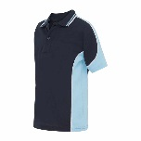  Duffield side panel sports polo Embroidered  5760MP |  | Children  4 6 8 10 12 14 16  Adults  S M L XL 2XL |  | Ch: $22.00  Ad: $26.00
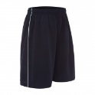  Reedman sport shorts  5766SP |  | Children  4 6 8 10 12 14 16 |  | Ch: $12.50
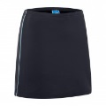  Watson sport skort  3762SP |  | Children  4 6 8 10 12 14 16 |  | Ch: $ 17.00
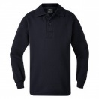  Fleecy Polo Neck – Embroidered - 5310WA |  | Children  4 6 8 10 12 14 16  Adults  S M L XL 2XL 3XL |  | Ch: $23.00  Ad: $28.00
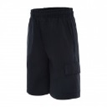  Phillip gaberdine cargo shorts - B586CS |  | Children  4 6 8 10 12 14 16 |  | Ch: $17.00
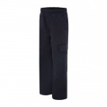  Kingston gabardine cargo trousers - B585CP |  | Children  4 6 8 10 12 14 16 |  | Ch: $20.00
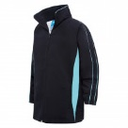  Kieran microfibre sport jacket – Embroidered  5339PJ |  | Children  4 6 8 10 12 14 16  Adults  S M L XL 2XL 3XL |  | Ch: $34.00  Ad: $40.00
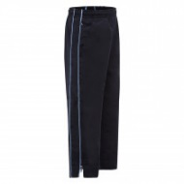  North microfibre track pants with piping  5338TS |  | Children  4 6 8 10 12 14 16  Adults  S M L XL 2XL 3XL |  | Ch: $23.00  Ad: $25.00
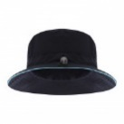  Burke Microfibre trim bucket hat – screen printed - T4331B |  | One size |  | Ch: $9.00
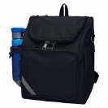  Kennedy Back Pack  J086BP |  | One size |  | Plain: $29.00  Emb: $ 34.00
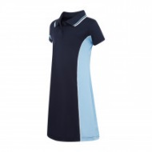  Harper polo dress – embroidered - 3764SB |  | Children  4 6 8 10 12 14 16 |  | Ch: $28.00
Totals

Parent Name: |  | Date:
Parent Signature:

